EMPATICA PLATFORM: USB PHONE READING

# Introduction

The Empatica platform relies on three devices:

* Empatica wristband
* Nexus 5 – smart phone
* Laptop

Empatica is wirelessly connected to the smartphone via Bluetooth. This connection is enabled thanks to the application in the phone **EmpaLink**.

The phone is wired to the laptop. This connection is enabled thanks to two programs (each hosted in one of the machines):

* **EmpaLink**, in the smartphone. The same application that connects with the wristband is used to perform USB functions
* **IITServerInterface**.exe (a java program), in the laptop. This is a program that
  1. Selects the excel file where values from Empatica will be written
  2. Uses adb.exe to perform port forwarding (when the adb path is set)
  3. Connects to the phone via USB
  4. Gets values from the phone and generates an excel file.

When everything is working, IITServerInterface.exe will generate an excel file (when we press the right button, every 5 minutes). This excel file is then read by MATLAB algorithm when ‘Run’ is pressed.

# Using the system

Setting up the system consists of two main steps:

1. Bluetooth connecting the Empatica to the phone
2. USB connecting the phone with the laptop

After setup is finished, we will be getting Empatica information every 5 min

## Connecting Empatica to the phone – using EmpaLink

The process of connecting Empatica is almost automatic. We just need to have an Internet connection and turn on the Empatica wristband in standby mode (Green light).

### Securing an Internet connection: WiFi Hotspot

In order to use Empatica, the phone needs to be connected to the **Internet**. Empatica has to perform a license verification to work. The verification is not required constantly (only at the beginning of the application and every ~30min). Which means that:

* If there is no Internet connection when EmpaLink is started, we will not connect to Empatica
* If Internet connection is lost afterwards (once Empatica is connected) the Bluetooth connection will eventually be cancel. However, the app will run for a certain amount of time till that happens

We count with a WiFi hotspot, to provide Internet during experiments. Unfortunately, we have seen how this connection is lost during exercise* (let’s hope Empatica stays connected if this happens).

Consequently, first step of the connection process: CONNECT THE SMARTPHONE TO THE WIFI HOTSPOT

*NOTE: When WiFi hotspot has no Internet and Empatica disconnects from the phone, we can set up a hotspot with our own personal phone

### Start screen in the app and turning ON Empatica

When EmpaLink start, it should start in the READY screen:

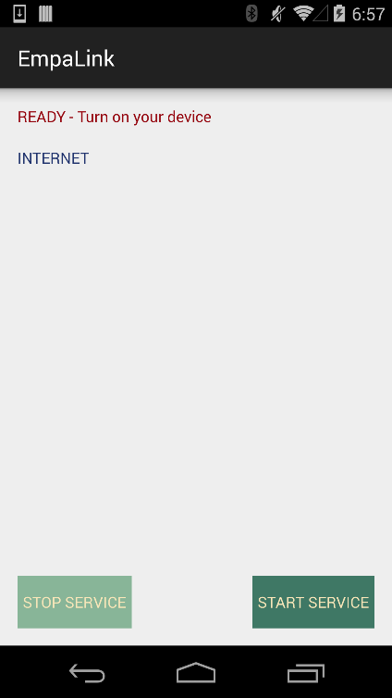

It will ask you to turn ON the Empatica device. Once Empatica is on (you see a green light blinking), the connection process will start till the device is connected and the main screen appears:

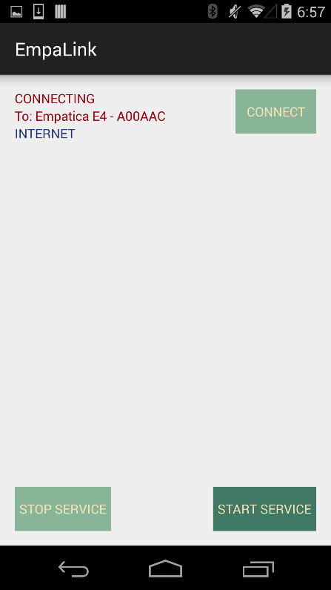 ----------------🡪 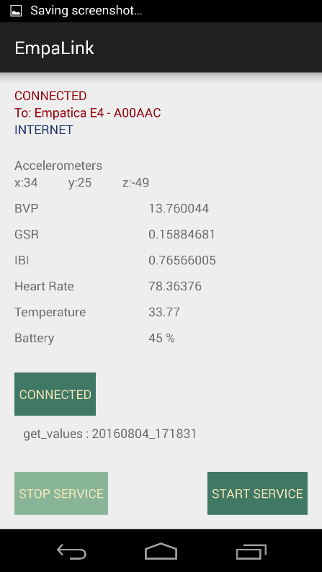

*** You may see it starts on the DISCONNECT screen(instead of the READY screen), if it tried to connect and failed before:

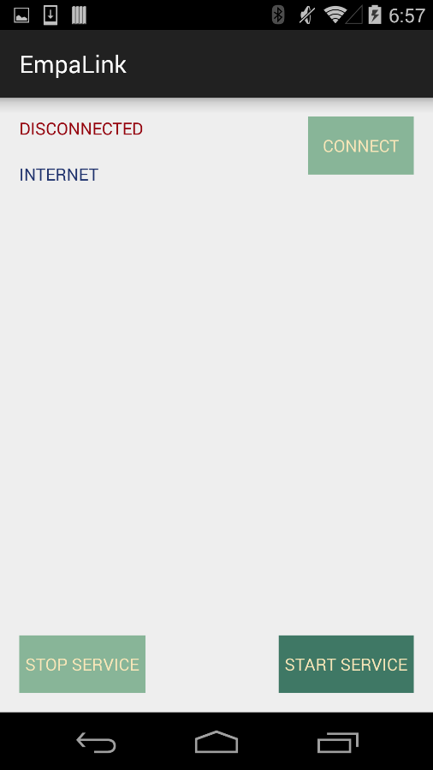

Press CONNECT to go to the READY screen

If there is no CONNECT button press STOP SERVICE and then START SERVICE, to go to the READY screen

*NOTE: INTERNET label will indicate if there is internet (INTERNET) or not (NO INTERNET)

### Main screen of EmpaLink



The main screen has four sections (from top to bottom):

* Connection Status – state of Bluetooth Connection to Empatica
* Streamed data – real time data from Empatica
* USB Connection:
  + USB Connect button
  + Received Command label (commands received from the phone)
* Service management buttons (to use for troubleshooting):
  + STOP Service – stops the app
  + START Service – restart the app

## Connecting the phone to the laptop – USB cable

To enable a USB connection between phone and laptop, we need to follow a three steps procedure (yes… it is not straightforward).

1. Port Forwarding – start laptop application. With the phone connected via USB to the computer, we start **IITServerInterface**.exe.
   * First, it will ask for the excel file in which we want to write Empatica values
   * Then, we will have to **enter the right path to adb.exe** . This file is part of Android SDK, and a copy is provided in ‘Empatica’ folder.

NOTE: path to adb.exe, from the ‘Empatica’ folder:

android-sdk-windows > platform-tools

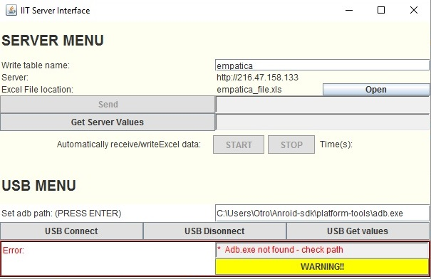

* + Once we enter the right path to adb.exe and PRESS ENTER, the port forwarding is performed

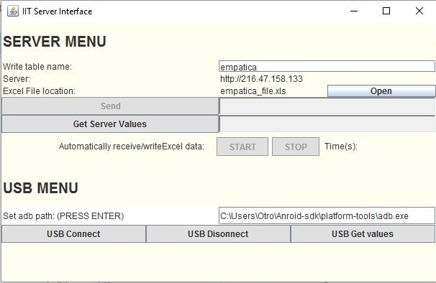

1. Start Host – server in the phone. **Press Connect USB in the phone**

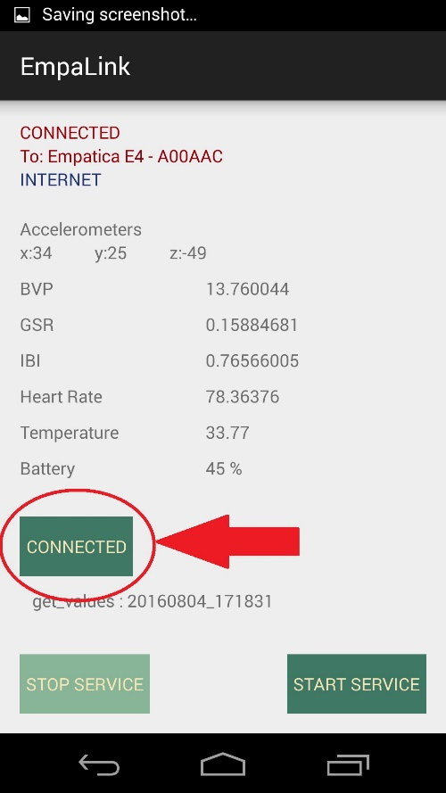

* + Popup messages in the phone:
    1. Attempting to connect
    2. Server Socket 38600 -0.0.0.0

1. Stat Client and request connection to server. **Computer press USB Connect button**.

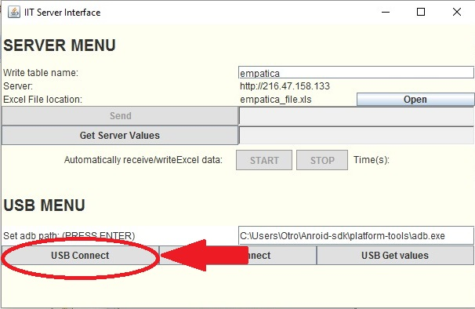

If the connection is successful

* Laptop java program:
  + CONNECT button changes:
    - Turns Green
    - Says CONNECTED
    - Is disabled

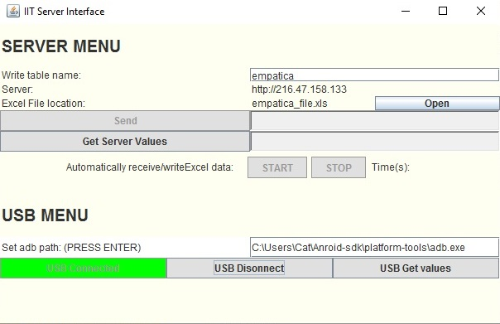

* Phone screen popups:
  + Connection successful
  + Socket in ****

****NOTE: When “**Socket In”** Pop up does not appear 🡪 PHONE WILL NOT RECEIVE COMMANDS FROM LAPTOP: we need to restart the phone and try the connection again

## Get data: Every 5 minutes

Press ‘USB Get values’ in the laptop

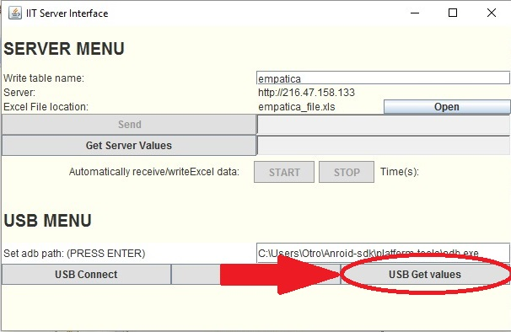

If the command is sent properly, we should also see a confirmation on the phone: in the USB Connection section (under the USB Connect button), there is a label that is updated every time a command is read.

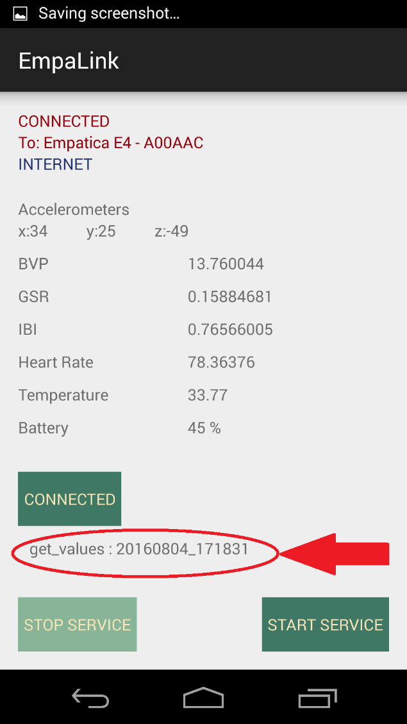

We can use it to see the time of the command

***Time format – YYYYMMDD_HHmmss***

When the command is received by the phone, the phone will sent all samples since the last time it sent any (usually, the last 5 minutes of data). Then, the laptop Java program will write this values in the excel file. When the excel file is being generated in the laptop, we can see that the program is processing the request (the get button is disabled and changes to ‘Getting values..’):

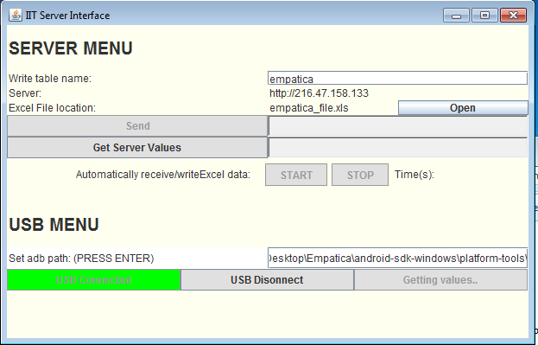

When the whole process is finished, the laptop program will generate a PopUp Window – to indicate the system is ready to run the MATLAB Algorithm.

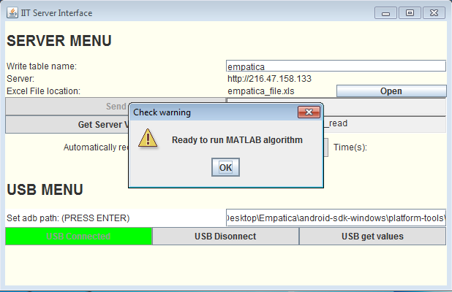

(*) When there is no data coming from the device or some issue with that data, the program will be **stuck in the ‘Getting Data..’ state for 3 minutes.** If this happens, verify whether:

* There is no data coming from the phone – it takes 1-2 minutes for the phone to generate a sample data from empatica values
* There is no problem on the excel file – open it and check the bottom values. Also, if there is any Fatal Error while opening, the program is malfunctioning. If something weird happens, we need to restart

## Empatica: how to basics

### Empatica button functions

Normal button press: press and hold for ~2seconds

Restart button press: press and hold for >5seconds

Basic functions of Empatica are:

* Turn ON – Normal button press (when device is OFF): hold button till a light appears (it can be green, or blue/red transitioning to green)
* Turn OFF – Normal button press (when device is ON): hold button till light goes off
* Start the device – Normal button press: hold button till a light appears

### Empatica light colors

Empatica has a blinking LED to indicate the state of the device. The possible colors are:

* **GREEN** – Standby mode (it will later go to either recording or streaming)
* **RED** – Recording mode
* **BLUE** – Streaming (via Bluetooth)
* WHITE – Restarting
* OCCASIONAL **YELLOW** – Low battery

# Other functions of the java program on laptop

## Change Excel file

In Server Menu, we can see the ‘**Excel File location’**. If we ever need to change this file, we can press the open button close to the file and browse the computer to select the new file

## Server get table values

In Server Menu, the only enabled button is the “**Get**”. It will download all values from IIT Server’s database (the one on Siegel Hall) and write them on the selected excel file.

It will look for the values in the table with the name shown in “**Write table name**” (it can also be changed entering a new name in the field and pressing ENTER).

# Recommendations

## Don’ts

There are some actions that the Java program in the laptop does not take very happily. Until I can fix them, I would recommend:

* Do not disconnect the phone from the computer: do not remove the USB cable. It will require a restart of the whole system (Java program in the laptop and Android application in the phone)
* Do not modify the excel file manually. For some reason, the program may start writing wrong data afterwards

# Troubleshooting

The bottom of the Java program will show any exception thrown by the code. Sometimes, these exceptions do not affect the program (and we can continue without restarting), while others are critical.

When the exception can be ignored, the program will just show the warning on the bottom of the screen. You should dismiss the exception (press WARNING button) and, when the execution is over, check that the excel file is alright.

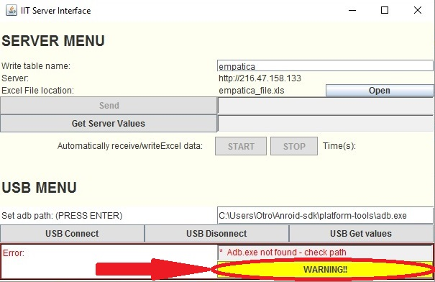

When the exception is critical, it will show the warning aaaaaand a pop up Window with more information

## While stablishing the connection

This is the most problematic part: getting the USB connection enabled. Most of the issues appear when reconnecting, when the previous socket (from the previous execution) is not closed properly or some previous services are still running.

Establishing the connection may fail for several reasons:

1. Adb.exe path is not enter properly. The laptop program will always show the Warning Adb.exe not found warning.
2. Port forwarding was not possible. The Warning section will show:

*Cannot start Android bridge! error:nodevices/emulatorsfound*

This means no Android device was recognized by the system:

* Check that the phone is connect to the computer via USB
* If it is connected, there is usually problem with the phone driver:
  1. Go to Device Manager > Manual Devices and find the phone
  2. Right click on the device and ‘Update Driver’
  3. Select file from the computer
  4. The driver is inside ‘Empatica’ folder. Navigate to Empatica >android-sdk-windows >extras>google>usb_driver and select with subfolders

After the installation of the new driver, you should disconnect and reconnect the phone to the computer via USB.

1. In the phone, when pressing “USB Connect” – make sure that the **Socket server – 38600 0.0.0.0** (or similar numbers) appears.

If the popup does NOT appear – the phone is already using that socket. We have to restart:

* First, only restart EmpaLink app –
  1. open the running apps menu and close it.
  2. Disconnect USB cable and connect again.
  3. In the laptop, press enter on the adb.exe path (to verify portforwarding works)
  4. Stat Android app again and try to reconnect.
* If restarting the app does not work, TURN OFF and ON the phone and start the connection again

1. In the laptop, when pressing “USB Connect”
   1. Socket error – an exception appears in the Warning section
   2. In the phone – make sure that the “**Socket In”** pop up appears

If the pop ‘**Socket In’** DOES NOT appear:

* Press USB Disconnect in IITServerInterface (in the laptop)
* Close Empatica application
* Disconnect phone from USB cable and connect phone again
* Recheck port forwarding (press enter in the ‘Set adb path’ field)
* Start empatica application again and follow steps to connect.
* If socket In does not appear still 🡪 Restart phone.

1. When pressing “Get USB values” no command appears on the phone screen. The connection was not configured properly (even if everything indicates it is ok).
   1. Restart the phone and disconnect the USB cable
   2. Close IITServerInterface.exe in the computer
   3. Stop adb.exe service. Open “Task Manager” in the computer, right click adb.exe, >Stop service
   4. Start the connection process from the beginning
2. After pressing “Get USB values”, we see the command on the phone but the Java application gets stuck on “Getting values..” (it comes back after 3 minutes, but the MATLAB ready pop up window does not show in the computer). There was some problem decoding and writing, and most probably the excel file will be corrupted. It happened when the phone send empatica data samples, but not the ‘end_sample’ command to indicate there was not more data coming in.

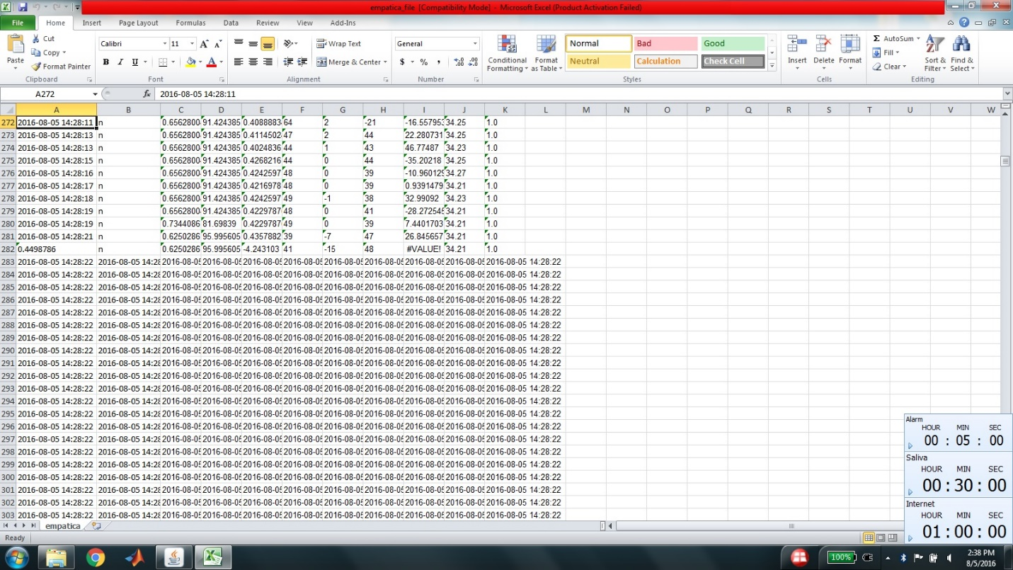

*Last rows are fill with times only

In this case we need to:

* Erase all values from excel file, EXCEPT the first row (we need to keep each column name!!!)
* Restart the Java program and try to reconnect to the phone.
* Empatica application may need to be closed and open again, if the previous step does not work by itself.

## While running the program

### Exceptions which we can ignore:

While running the program in the computer, some exceptions may appear that can cause the lost of 1 minute data, but will not affect future running of the program.

#### JSONArray Exception: a Json array must start with ‘[‘

This Exception appears when one of the data samples sent from the phone cannot be decoded by the computer.

* If it is one real sample – it will cost the lost of 1minute of data sample
* If it is the end command(*) – nothing will be lost

(*)NOTE: When the phone send the last sample to the computer, it will send an “end_sample”. Generally, the laptop program does not compute it, but if it tries to decode it the exception will happen.

In both cases, when the execution of “Get USB values” finishes, you should **open the excel** file and check the values.

#### Jxl.read.biff.BiffException: The input file was not found

This Exception happens in two situations:

* Excel file is open – in this case, we would lost 5 minutes of data and the exception will appear several times (one for each time the program tries to write the excel file). The excel file must be closed immediately.
* Excel file is closed, but the Exception appears – not sure why this happens, but the data is stored regardless. when the execution of “Get USB values” finishes, you should **open the excel** file and check the values.

NOTE: Before the “Matlab is ready” windows appears on the computer, the error will be seen several times (each time a data samples tries to be written in the excel file).

Excel file state: it can either be

1. In perfect state, just like a normal execution
2. Samples stored in disorder! It may affect the MATLAB algorithm – press again “USB get values” to generate a correct file.

### Fatal exceptions which require the program to be restarted:

#### Could not initialize I/O on Socket

This exception is directly related with the USB connection! If it appears, it means that, for whatever reason, the connection is not properly stablished.

It will need the whole system to restart.

<I will update this list if I see something new>